

RFID Student Tracking System

Software Functional Specifications

Usman Zafar 06-0088

Abdul Rehman Shafique Durrani 06-0104

Muhammad Ahsan Iqbal 06-0102  
Fahad Tariq 06-0132

Supervisor: Dr. Muhammad Usman Bhatti

Project Manger: Dr. Muhammad Usman Bhatti

BS (CS) Final Year Project

Date: 3rd October 2009

National University Of Computer and Emerging Sciences

Department of Computer Science

Lahore, Pakistan

Table of Contents

1. Introduction 4

1.1 Purpose of this Document 4

1.2 Intended Audience 4

1.3 Definitions, Acronyms, and Abbreviations 5

2. General Description 5

2.1 User Characteristics 5

2.2 Domain Overview 5

3. Functionality 6

3.1 Functional Requirements 6

3.2 Non-Functional Requirements 7

4. System Architecture 7

5. Use Cases 8

5.1 Use-Case Name 8

5.1.1 Brief Description 8

5.1.2 Actor 8

5.1.3 Basic Flow 8

5.1.4 Pre-conditions 8

5.1.5 Post-conditions 8

5.2 Use-Case Name 8

5.2.1 Brief Description 8

5.2.2 Actor 8

5.2.3 Basic Flow 8

5.2.4 First Alternative Flow 8

5.2.5 Pre-conditions 8

5.2.6 Post-conditions 9

5.3 Use-Case Name 9

5.3.1 Brief Description 9

5.3.2 Actor 9

5.3.3 Basic Flow 9

5.3.4 Pre-conditions 9

5.3.5 Post-conditions 9

5.4 Use-Case Name 9

5.4.1 Brief Description 9

5.4.2 Actor 9

5.4.3 Basic Flow 10

5.4.4 First Alternative Flow 10

5.4.5 Pre-conditions 10

5.4.6 Post-conditions 10

5.5 Use-Case Name 10

5.5.1 Brief Description 10

5.5.2 Actor 10

5.5.3 Basic Flow 10

5.5.4 First Alternative Flow 10

If a student is not allowed to enter the university, the system will notify the student that he/she is not allowed to enter the vicinity of university campus. 10

5.5.5 Pre-conditions 10

5.5.6 Post-conditions 10

5.6 Use-Case Name 11

5.6.1 Brief Description 11

5.6.2 Actor 11

5.6.3 Basic Flow 11

5.6.4 First Alternative Flow 11

If a student is not allowed to enter the hostels, the system will notify 11

the student that he/she is not allowed to enter the hostels. 11

5.6.5 Second Alternative Flow 11

5.6.6 Pre-conditions 11

5.6.7 Post-conditions 11

6. Graphical User Interfaces 12

7. Database Design. 15

7.1 ER Diagram 15

7.2 Data Dictionary 15

8. Risk Analysis 30

9. System Requirements 30

9.1 Hardware Requirements 30

9.2 Software Requirements 30

10. References 31

11. Appendix **Error! Bookmark not defined.**

# Introduction

The purpose of this project is to automate tracking of the presence of student at different locations of the university, with the intention of bringing transparency and reducing number of errors that usually happen in such tasks. We are using radio frequency identification (RFID) technology in the project for security and attendance purposes.

Radio frequency identification (RFID) consists of a transmitter chip/IC and a receiving antenna. Each chip has a unique identification number commonly referred to as a RFID Tag, which is attached to the object that we want to identify. Now the RFID tags are detected and identified using an antenna or a scanning device known as transceiver, which with the help of radio signals identifies the tag, the object. In this project, the RFID tags will be associated, to the students (by attaching the RFIDs to student’s university cards) and the transceivers will be placed on the entry points of various locations of the campus. Software at the back end will keep and manage the records, concerning the student’s entry to the respective areas, associated with time and other aspects required. All the use-cases will be accomplished using software having application and databases layers. Concepts of Object orientation will be followed in the design of the system.

## Purpose of this Document

The purpose of this project is the complete automation of student’s records concerning their presence in different locations of the campus, so that the possibility of human errors, while taking and displaying attendance related information, or while locating the student at a required time for disciplinary issues (like knowing the presence of the student when the regulations of a place like examination hall or library were violated), making it a sole responsibility of the system to record the student’s presence, thus making entries and retrievals of information a fast and reliable task.

Another purpose is maintaining a record of entries and providing an interface for querying. Authenticated entry of required/allowed students only on various places in the campus can also be achieved in this project.

## Intended Audience

The intended audience of this project is:

* Students:

They are the primary users of the system as; they are to be identified through the identification chips, as the record of the student’s presence is the key information of the system.

* Faculty:

Faculty will be provided the access to the database information of student’s monthly attendance, so that their opinion can influence the system only in cases where system fails e.g. If the student forgets the card with the chip, or has not been allotted a card yet.

* Staff of university:

The university staff will have complete access to the services of the database like reporting services, data extraction, record updating etc. Staff includes librarian, hostel superintendent, security personnel etc.

* Administrator:

The administrator will be responsible to insert, delete, search, update or use the information of students, faculty and staff in any way.

## Definitions, Acronyms, and Abbreviations

| Term | Description |
| --- | --- |
| RS | Requirements Specifications |
| FS | Functional Specifications |
| RFID | Radio Frequency Identification |
| DBMS | Data Base Management System |
| UC | Use Case |
| UI | User Interface |

# General Description

## User Characteristics

The Users and their characteristics are:

* Students:

The student as far as this project is concerned is to have the RIFD chip with them, which is their basic characteristic and they themselves should make it necessary to get the RFID chip scanned through the scanner to make their entry in the database.

* Faculty:

Faculty in the project will only be provided with an interface through which they can modify the information regarding attendance only in the system. Their role in the project will only be at times where exceptional cases like system failure or unavailability of cards to the new batch occurs.

* Staff of university:

The university staff will have interfaces so that they can control the overall system as the entry and retrieval of data is concerned, record updations, reporting services to support information in different views etc. Thus their role is just to perform the backend data manipulation operations.

* Administrator:

The administrator will be provided interfaces to maintain personal and login information of students, faculty and staff. Administrator will be able to insert, delete, search and update their records.

## Domain Overview

The system focuses on automation of tasks regarding academia and concerning the student’s physical presence within the campus area e.g. class attendance, examination/student authentication, and library identification. The intended automation is to be achieved using Radio-frequency Identification (RFID) using RFID chips having unique identification id and their scanners/antennas. All the data collected by the above mentioned method will be stored for further processing eliminating the possibility of human involvement in keeping a track of student’s physical presence.

# Functionality

## Functional Requirements

The key functionalities of our system are as follows:

* Student’s attendance in the classrooms and the time they consume outside the classroom after attendance during class timings. Implementation of filters to maintain academic policies.
* Entrance of students in labs can be restricted using RFID. If a lab session of a particular course is going on in some lab, then an RFID scan can be planted on the entrance of lab to make sure that only those students could enter the lab who are registered in that course.
* Maintaining records at the time of issuance and retrieval of books making it easier for the librarians to manage a large number of people in less time as now only the RFID is needed to be scanned only.
* Examination safety and check by making sure that only the allowed person has entered the examination hall/room and not somebody else by displaying an image of the student at the nearby display screen on which probably the examiner can assure the authentication of the student.
* Student presence in university (checked through entrance from main gate) is required to see whether a student was present on the eve of special incident or against the violation of university regulations as some DC notices require student to remain beyond the vicinity of the campus.
* Their Hostel records that includes IN and OUT timings of each student from the hostel are required to keep a check on them. Hostel administration can take decisions of fine/penalty etc in case of entry in hostel at night after the allowed time or leaving/entering the hostel when it is not allowed
* Students, faculty, staff and administrator should be given an interface and they can sign into their accounts and use the application according to the rights given to them.
* Students can view their attendance using the interface provided to them in our application.
* Faculty can view, insert, delete and update attendance records of any student, who is registered in the courses, they are teaching.
* Staff can view, insert, delete and update student records for various purposes.
* Administrator can insert, delete, search and update personal information as well as login information records of students, faculty and staff.
* Administrator, staff and faculty can generate reports using the available data on the system.
* Administrator can blacklist any user by blocking his/her access to software (block login id and password) as well as RFID hardware (block tag id). Staff and faculty can also request administrator to blacklist any student. Administrator can also blacklist any staff and faculty member from system access.

## Non-Functional Requirements

* The tag and the scanner should not be more than 10 – 15 centimeters apart to make a proper entry.
* The scanning of the RFID tag is a hardware dependant tasks thus at a time a scanner will only scan one tag but the entry in the database should take not more than 3 seconds of tag scan.
* In case the database entry takes more than 3 seconds the entry will be dropped and proper notification of misreading of information will be displayed.
* In case of power failures the database should have the capability to rollback, and a proper notification is to be given to the scanning end whether the last read information is reflected in the database or not.
* The system is windows OS based (XP and later versions).
* The network specifications should at least have a data transfer capacity of (100 Mbps) minimum Ethernet available speed.
* The memory capacity of volatile memory (RAM) should be between 512 MB – 1GB and processing capacity more than 2 GHz to smoothly run the and handle the overall system.

# System Architecture

RFID Tag Data

(Embedded on Id Cards of students)

Transceiver Data

Reports/Output

Library

DBMS

Interface/GUI

Identification

**Rights**

Academic

Main Entrance

Hostels

**Application Layer**

**Tracking**

Admin

Student

Faculty

Staff

**History maintenance**

# Use Cases

**Use Case Diagram:**



## Use-Case Name

UC-1: Student’s attendance

### Brief Description

This use case involves automated attendance of a student using RFID. The purpose of this use case is to mark the presence or absence of student keeping track of time.

### Actor

Student

### Basic Flow

Student takes RFID transmitter close to the receiver such that it comes in its range.

System will update the attendance record of a particular student after identifying the chip ID.

### Pre-conditions

The receiver is in working order and is ready (wait state) to receive RFID signals.

### Post-conditions

The scanner (receiver) will beep or an LED will glow as a response to affirmative attendance.

## Use-Case Name

UC-2: Entrance of students in lab

### Brief Description

This use case involves restricted entrance of a student in lab using RFID. The purpose of this use case is to make sure that only those students should enter the lab that are registered for a particular course whose lab session is going on.

### Actor

Student

### Basic Flow

Student takes RFID transmitter close to the receiver, placed at the door of lab, such that it comes in its range.

System will identify the chip ID and in case of valid student, it will open the door of lab.

### First Alternative Flow

If the student is not registered in the course, system will not open the door and some signal/message in form LED etc will inform the student that lab session is going on in lab.

### Pre-conditions

The receiver outside the lab is in working order and is ready (wait state) to receive RFID signals.

### Post-conditions

The system will either open the door for the student or will show a signal that lab session is going on.

## Use-Case Name

UC-3: Book issuance from library

### Brief Description

This use case involves issuance of book to a student in library using RFID. The purpose of this use case is to automate the entrance of record of a student in databases who is willing to get books issued.

### Actor

Student

### Basic Flow

Student takes RFID transmitter close to the receiver, placed on desk of librarian, such that it comes in its range.

System will identify the chip ID and will save student’s record in databases.

Librarian will enter essential information regarding book, against student record that is retrieved through RFID.

System will generate and display the due date, for returning the books, to the student.

### Pre-conditions

The receiver in the library is in working order and is ready (wait state) to receive RFID signals.

### Post-conditions

The system will save record of student in databases who has got books issued and will display due date for returning book.

## Use-Case Name

UC-4: Entrance of students in examination hall

### Brief Description

This use case involves restricted entrance of a student in examination hall using RFID. The purpose of this use case is to make sure that only those students should enter the examination place that are allowed for a particular examination which is going on.

### Actor

Student

### Basic Flow

Student takes RFID transmitter close to the receiver, placed at the door of examination place, such that it comes in its range.

System will identify the chip ID and in case of valid student, it will open the door.

### First Alternative Flow

If the student is not allowed in the particular examination, system will not open the door and some signal/message in form LED etc will inform the student that he/she cannot enter the examination place.

### Pre-conditions

The receiver outside the examination place is in working order and is ready (wait state) to receive RFID signals.

### Post-conditions

The system will either open the door for the student or will show a signal that he/she cannot enter the examination place.

## Use-Case Name

UC-5: Student’s entrance in university

### Brief Description

This use case involves restricted entrance of a student in vicinity of university using RFID. The purpose of this use case is to make sure that only those students should enter the university who are allowed.

### Actor

Student

### Basic Flow

Student takes RFID transmitter close to the receiver such that it comes in its range.

System will update the record of a particular student (including time of entrance/exit) after identifying the chip ID.

### First Alternative Flow

### If a student is not allowed to enter the university, the system will notify the student that he/she is not allowed to enter the vicinity of university campus.

### Pre-conditions

The receiver on entrance of university is in working order and is ready (wait state) to receive RFID signals.

### Post-conditions

The scanner (receiver) will beep or an LED will glow as a response to affirmative attendance.

## Use-Case Name

UC-6: Student’s entrance in hostels

### Brief Description

This use case involves restricted entrance of a student in hostel premises using RFID. The purpose of this use case is to make sure that only those students should enter the hostels who are allowed. Also any student can enter the hostels only in allowed timings.

### Actor

Student

### Basic Flow

Student takes RFID transmitter close to the receiver such that it comes in its range.

System will update the record of a particular student (including time of entrance/exit) after identifying the chip ID.

### First Alternative Flow

### If a student is not allowed to enter the hostels, the system will notify

### the student that he/she is not allowed to enter the hostels.

### Second Alternative Flow

If a student tries to enter the hostels on odd timings, the system will notify the student that he/she is not allowed to enter the hostels for a particular period of time.

### Pre-conditions

The receiver on entrance of hostel is in working order and is ready (wait state) to receive RFID signals.

### Post-conditions

The scanner (receiver) will beep or an LED will glow as a response to affirmative attendance.

## Use-Case Name

UC-7: Login

### Brief Description

This use case involves right-protected login of student, faculty, staff and administrator in the application. The purpose of this use case is to provide an interface to the intended audience of the system so that they can sign into their respective accounts using a username and password. After successful login, an interface will be provided according to user category and its privileges.

### Actor

Student, faculty, staff, administrator

### Basic Flow

User enters username, password and selects user category. Then user presses the login button.

System responds with a new interface after verification of given information.

### First Alternative Flow

### If username/password/user category entered by the user is wrong, the system will show an error message that the information given to system is not correct and the user will have to re-type required information unless a valid user is login successfully.

### Pre-conditions

Login page has been displayed to the user.

### Post-conditions

User will be moved to the next page.

## Use-Case Name

UC-8: View attendance

### Brief Description

This use case involves the functionality of viewing attendance records of any student. The purpose of this use case is to provide an interface to the students and faculty so that they can view the attendance records for various purposes.

### Actor

Student, faculty, staff (hostel superintendent)

### Basic Flow

User enters roll number of the student. Then user presses the ‘view attendance’ button.

System responds with a new interface having attendance records of that particular student whose roll number was entered by the user.

### First Alternative Flow

### If no student exists against the roll number entered by the user, the system will show an error message that the roll number is not correct and the user will have to re-type the roll number unless a valid roll number is entered.

### Second Alternative Flow

If no record exists against the student whose roll number has been entered by the user, the system will show an error message that no attendance record exists against the given roll number.

### Pre-conditions

Interface for viewing attendance has been displayed to the user.

### Post-conditions

Attendance records have been shown to the user.

## Use-Case Name

UC-9: View student records through RFID

### Brief Description

This use case involves the functionality of viewing library or other records associated with any student. The purpose of this use case is to provide an interface to the staff like librarian so that they can view the student’s library records for return of books or further book issuance.

### Actor

Staff (Librarian)

### Basic Flow

Librarian takes RFID transmitter close to the receiver, placed near librarian, such that it comes in its range.

System will identify the chip ID and in case of valid student, it will open an interface on the system having complete library records of that student.

### Pre-conditions

The receiver in the library is in working order and is ready (wait state) to receive RFID signals. Interface for viewing student’s library records has been displayed to the user.

### Post-conditions

Library records of the student have been shown to the user.

## Use-Case Name

UC-10: Edit attendance records

### Brief Description

This use case involves the functionality of inserting, deleting or updating attendance records of any student. The purpose of this use case is to provide an interface to the faculty and staff (superintendent) so that they can edit the attendance records of students in exceptional cases.

### Actor

Faculty, staff (hostel superintendent)

### Basic Flow

After following UC-8, user can insert, delete, modify or update attendance record of the student by first selecting the functionality by pressing delete button, insert button or update button and then making changes in displayed attendance records. Then user presses the ‘save’ button.

System responds with a new interface with a message box having ‘changes have been saved’ over updated attendance records of the particular student.

### Pre-conditions

Attendance of a student has been displayed to the user and user can make changes in the attendance records.

### Post-conditions

Attendance records have been successfully updated and saved.

## Use-Case Name

UC-11: Search complete information records

### Brief Description

This use case involves the functionality of searching records regarding personal and login information of students, faculty or staff. The purpose of this use case is to provide an interface to the administrator so that he/she can search the records of students, faculty or staff for various purposes.

### Actor

Administrator

### Basic Flow

After following UC-7, user can select any user category from among the student, faculty or staff. Then administrator enters id of person whose records are to be searched and then presses ‘Search’ button.

System responds with a new interface having complete personal and login information records of the required person.

### Pre-conditions

Administrator has login to his account and an interface has been displayed to him/her giving options to select user category whose information has to be searched.

### Post-conditions

Complete information records of the required person have been displayed.

## Use-Case Name

UC-12: Edit information records

### Brief Description

This use case involves the functionality of inserting, deleting or updating information records of any student (by staff) or even of faculty and staff (by administrator). The purpose of this use case is to provide an interface to the administrator and staff so that they can edit the information records according to their requirements.

### Actor

Administrator, staff (librarian)

### Basic Flow

After following UC-9 (for librarian) or UC-11 (for administrator), user can insert, delete, modify or update attendance record of the student (by staff) or even of faculty and staff (by administrator) by first selecting the functionality by pressing delete button, insert button or update button and then making changes in displayed information records. Then user presses the ‘save’ button.

System responds with a new interface with a message box having ‘changes have been saved’ over updated information records of the required person.

### Pre-conditions

Required Information has been displayed to the user and user can make changes in these records.

### Post-conditions

Information records have been successfully updated and saved.

## Use-Case Name

UC-13: Generate reports

### Brief Description

This use case involves the functionality of generating any type of reports available on the system. The purpose of this use case is to provide an interface to the administration, faculty and staff so that they can generate reports of the data that is available to them.

### Actor

Administrator, faculty, staff

### Basic Flow

User retrieves the required data by following any use case. Then user presses the ‘generate report’ button.

System responds with a new interface having preview of the required report. Then user may get print out of that report.

### Pre-conditions

Interface for generating report has been displayed to the user.

### Post-conditions

Report has been displayed to the user.

## Use-Case Name

UC-14: User blacklist

### Brief Description

This use case involves the functionality of blocking any user from using the system including software and RFID hardware. The purpose of this use case is to provide an interface to the administration, faculty and staff so that they can blacklist any student to access the system in some unusual circumstances. Only administrator has the authority/rights to blacklist any user. Faculty/staff can request to administrator for this purpose.

### Actor

Administrator, faculty, staff

### Basic Flow

Faculty/staff enters roll number of the blacklisted student and press a button on their interface to send request to administrator.

System responds to faculty/staff with a confirmation message box after sending a message to the administrator. Then administrator blacklists the login information/password and RFID-Tag ID of the particular student.

### Pre-conditions

Interface for blacklisting potentially harmful user has been displayed to the actors of this use case.

### Post-conditions

Confirmation message of successful blocking of user has been displayed to the actors.

# Graphical User Interfaces

This section includes our proposed project (RFID Student Tracking System) mainly used screens.

Following is the proposed main screen of the targeted system.

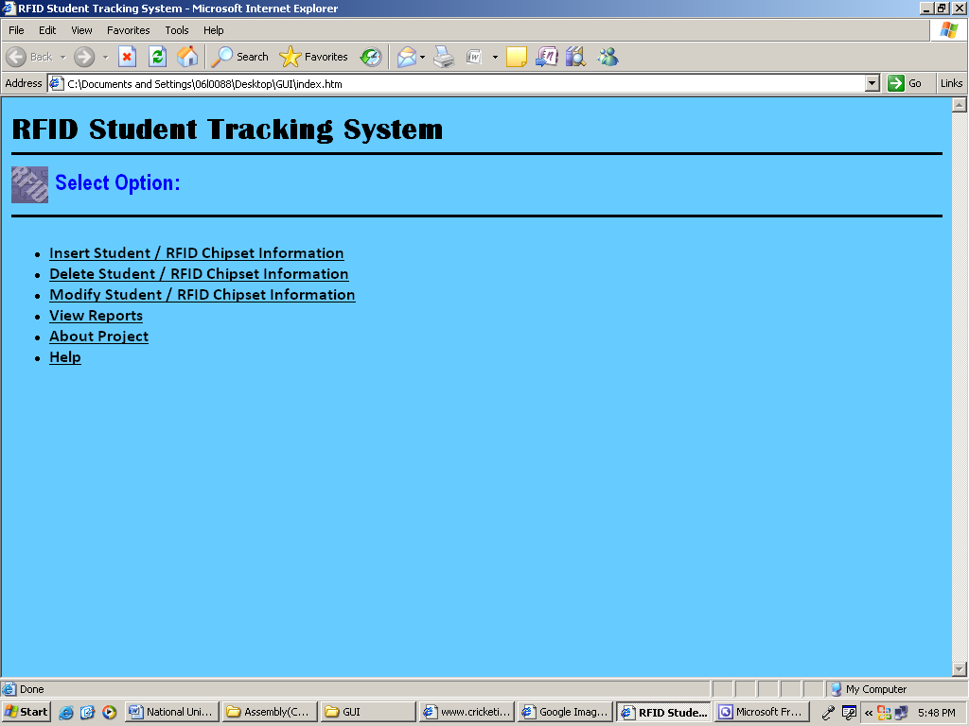

When inserting a student, following screen will be displayed. Same type of screens will be displayed when inserting RFID chipset information or when modifying either of already stored RFID Chipset or student information.

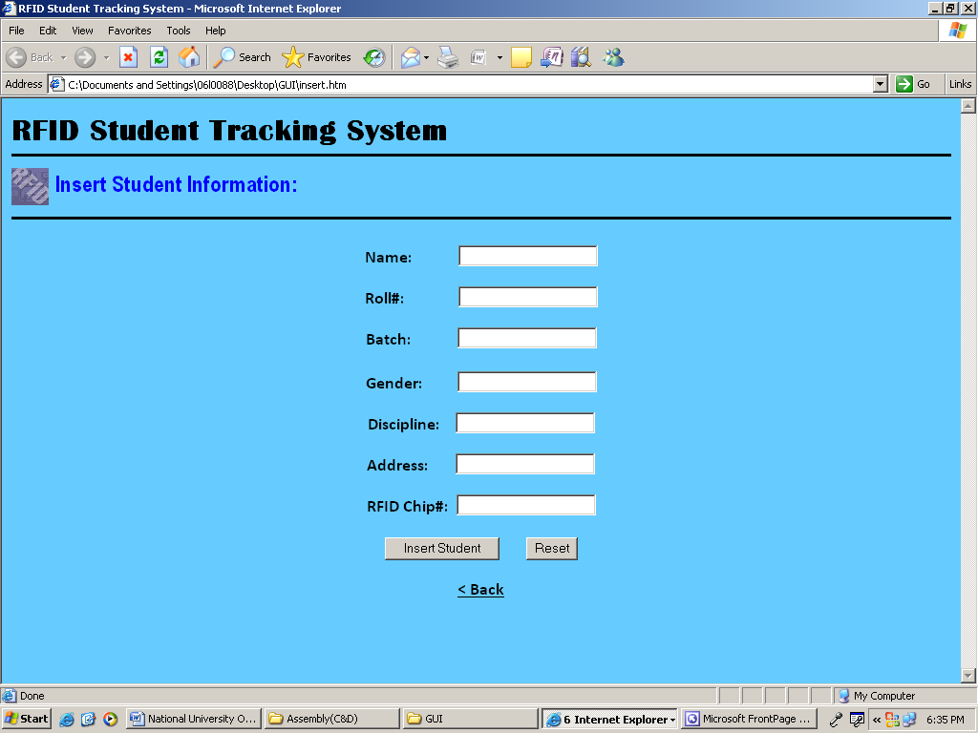

We can view the following reports within the system using the data stored in the database.

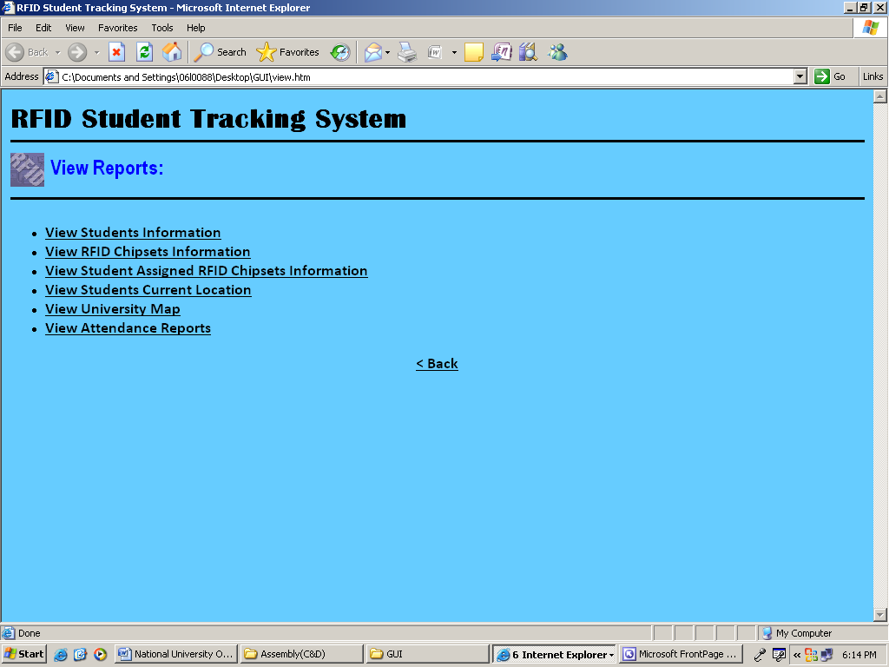

When viewing any type of reports like student information, RFID chipset information and attendance reports. Following type of screens are proposed.

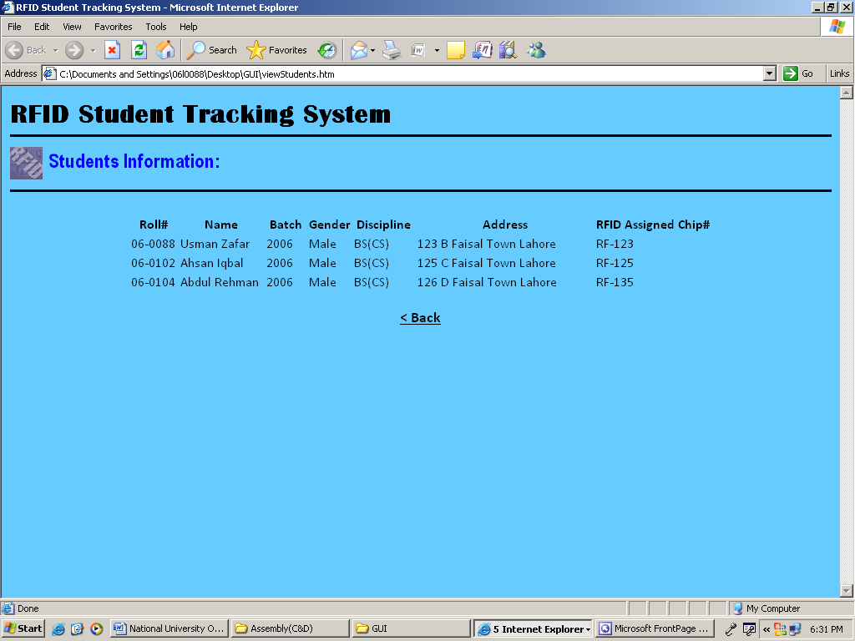

# Database Design.

## ER Diagram



## Data Dictionary

| **Entity** |
| --- |

| **Entity** | |
| --- | --- |
| **Name** | **Type** |
| Classroom | Independent |
| EntryChk | Dependent |
| Hostel | Independent |
| hostelattendance | Dependent |
| Lab | Independent |
| labattendance | Dependent |
| Library | Independent |
| Main-Entrance | Independent |
| RFID | Independent |
| stdattended | Dependent |
| Student | Independent |
| went to library | Dependent |

| **Attribute(s) of "Classroom" Entity** | | | | |
| --- | --- | --- | --- | --- |
| **Name** | **Definition** | **Is PK** | **Is FK** | **Logical Only** |
| cid | Unique Class room "id". | Yes | No | No |
| blockno | Block no , where class room is located. | Yes | No | No |
| entrancetime | Time on which student came in. | No | No | No |
| leavetime | Time on which student left. | No | No | No |

| **Is In Key Group(s) of "cid" Attribute** | |
| --- | --- |
| **Name** | **Type** |
| Primary Key | PK |

| **Is In Key Group(s) of "blockno" Attribute** | |
| --- | --- |
| **Name** | **Type** |
| Primary Key | PK |

| **Primary Key Attribute(s) of "Classroom" Entity** | |
| --- | --- |
| **Name** | **Is PK** |
| cid | Yes |
| blockno | Yes |

| **Attribute(s) of "EntryChk" Entity** | | | | |
| --- | --- | --- | --- | --- |
| **Name** | **Definition** | **Is PK** | **Is FK** | **Logical Only** |
| rfid-tag-id | Unique RFID tag value. | Yes | Yes | No |
| ent-id | Different entrances of university. | Yes | Yes | No |
| rollno | University roll no of student. | Yes | Yes | No |
| attendance | Attendance marking of student , through functionalities implementaion. | No | No | No |
| date | Date and time of attendance marking. | No | No | No |

| **Is In Key Group(s) of "rfid-tag-id" Attribute** | |
| --- | --- |
| **Name** | **Type** |
| Primary Key | PK |
| Foreign Key 1 | IF1 |

| **Is In Key Group(s) of "ent-id" Attribute** | |
| --- | --- |
| **Name** | **Type** |
| Primary Key | PK |
| Foreign Key 2 | IF2 |

| **Is In Key Group(s) of "rollno" Attribute** | |
| --- | --- |
| **Name** | **Type** |
| Primary Key | PK |
| Foreign Key 3 | IF3 |

| **Primary Key Attribute(s) of "EntryChk" Entity** | |
| --- | --- |
| **Name** | **Is PK** |
| rfid-tag-id | Yes |
| ent-id | Yes |
| rollno | Yes |

| **Attribute(s) of "Hostel" Entity** | | | | |
| --- | --- | --- | --- | --- |
| **Name** | **Definition** | **Is PK** | **Is FK** | **Logical Only** |
| hent-id | Unique hostel gates entry nos. | Yes | No | No |
| entrancetime | Student hostel entrance time. | No | No | No |
| leavetime | Student Hostel leaving time. | No | No | No |

| **Is In Key Group(s) of "hent-id" Attribute** | |
| --- | --- |
| **Name** | **Type** |
| Primary Key | PK |

| **Primary Key Attribute(s) of "Hostel" Entity** | |
| --- | --- |
| **Name** | **Is PK** |
| hent-id | Yes |

| **Attribute(s) of "hostelattendance" Entity** | | | | |
| --- | --- | --- | --- | --- |
| **Name** | **Definition** | **Is PK** | **Is FK** | **Logical Only** |
| hent-id | Unique hostel gates entry nos. | Yes | Yes | No |
| rfid-tag-id | Unique rfid tag. | Yes | Yes | No |
| rollno | University roll no of student. | Yes | Yes | No |
| attendance | To check whether present or absent. | No | No | No |
| date | Date and time of presence marking. | No | No | No |

| **Is In Key Group(s) of "hent-id" Attribute** | |
| --- | --- |
| **Name** | **Type** |
| Primary Key | PK |
| Foreign Key 1 | IF1 |

| **Is In Key Group(s) of "rfid-tag-id" Attribute** | |
| --- | --- |
| **Name** | **Type** |
| Primary Key | PK |
| Foreign Key 3 | IF3 |

| **Is In Key Group(s) of "rollno" Attribute** | |
| --- | --- |
| **Name** | **Type** |
| Primary Key | PK |
| Foreign Key 4 | IF4 |

| **Primary Key Attribute(s) of "hostelattendance" Entity** | |
| --- | --- |
| **Name** | **Is PK** |
| hent-id | Yes |
| rfid-tag-id | Yes |
| rollno | Yes |

| **Attribute(s) of "Lab" Entity** | | | | |
| --- | --- | --- | --- | --- |
| **Name** | **Definition** | **Is PK** | **Is FK** | **Logical Only** |
| lab-id | Unique id of laboratory. | Yes | No | No |
| blockno | Specific block in which lab is located. | Yes | No | No |
| entrancetime | Time on which student entered the lab. | No | No | No |
| leavetime | Time on which student left the lab. | No | No | No |

| **Is In Key Group(s) of "lab-id" Attribute** | |
| --- | --- |
| **Name** | **Type** |
| Primary Key | PK |

| **Is In Key Group(s) of "blockno" Attribute** | |
| --- | --- |
| **Name** | **Type** |
| Primary Key | PK |

| **Primary Key Attribute(s) of "Lab" Entity** | |
| --- | --- |
| **Name** | **Is PK** |
| lab-id | Yes |
| blockno | Yes |

| **Attribute(s) of "labattendance" Entity** | | | | |
| --- | --- | --- | --- | --- |
| **Name** | **Definition** | **Is PK** | **Is FK** | **Logical Only** |
| rfid-tag-id | UNique rfid tag value. | Yes | Yes | No |
| lab-id | Unique id of laboratory. | Yes | Yes | No |
| blockno | Specific block in which lab is located. | Yes | Yes | No |
| rollno | University roll no of student. | Yes | Yes | No |
| attendance | To check whether absent or present. | No | No | No |
| date | The date and time to check absence or presence. | No | No | No |

| **Is In Key Group(s) of "rfid-tag-id" Attribute** | |
| --- | --- |
| **Name** | **Type** |
| Primary Key | PK |
| Foreign Key 1 | IF1 |

| **Is In Key Group(s) of "lab-id" Attribute** | |
| --- | --- |
| **Name** | **Type** |
| Primary Key | PK |
| Foreign Key 2 | IF2 |

| **Is In Key Group(s) of "blockno" Attribute** | |
| --- | --- |
| **Name** | **Type** |
| Primary Key | PK |
| Foreign Key 2 | IF2 |

| **Is In Key Group(s) of "rollno" Attribute** | |
| --- | --- |
| **Name** | **Type** |
| Primary Key | PK |
| Foreign Key 3 | IF3 |

| **Primary Key Attribute(s) of "labattendance" Entity** | |
| --- | --- |
| **Name** | **Is PK** |
| rfid-tag-id | Yes |
| lab-id | Yes |
| blockno | Yes |
| rollno | Yes |

| **Attribute(s) of "Library" Entity** | | | | |
| --- | --- | --- | --- | --- |
| **Name** | **Definition** | **Is PK** | **Is FK** | **Logical Only** |
| lib-id | Unique library Id | Yes | No | No |
| blockno | Block no of building in which | Yes | No | No |
| entrancetime | Entrance time of student. | No | No | No |
| leavetime | Leaving time of student. | No | No | No |

| **Is In Key Group(s) of "lib-id" Attribute** | |
| --- | --- |
| **Name** | **Type** |
| Primary Key | PK |

| **Is In Key Group(s) of "blockno" Attribute** | |
| --- | --- |
| **Name** | **Type** |
| Primary Key | PK |

| **Primary Key Attribute(s) of "Library" Entity** | |
| --- | --- |
| **Name** | **Is PK** |
| lib-id | Yes |
| blockno | Yes |

| **Attribute(s) of "Main-Entrance" Entity** | | | | |
| --- | --- | --- | --- | --- |
| **Name** | **Definition** | **Is PK** | **Is FK** | **Logical Only** |
| ent-id | Different entrances of university. | Yes | No | No |
| entrancetime | Time on which student entered through the particular gate of university. | No | No | No |
| leavetime | Time on which student left through the particular gate of university. | No | No | No |

| **Is In Key Group(s) of "ent-id" Attribute** | |
| --- | --- |
| **Name** | **Type** |
| Primary Key | PK |

| **Primary Key Attribute(s) of "Main-Entrance" Entity** | |
| --- | --- |
| **Name** | **Is PK** |
| ent-id | Yes |

| **Attribute(s) of "RFID" Entity** | | | | |
| --- | --- | --- | --- | --- |
| **Name** | **Definition** | **Is PK** | **Is FK** | **Logical Only** |
| rfid-tag-id |  | Yes | No | No |

| **Is In Key Group(s) of "rfid-tag-id" Attribute** | |
| --- | --- |
| **Name** | **Type** |
| Primary Key | PK |

| **Primary Key Attribute(s) of "RFID" Entity** | |
| --- | --- |
| **Name** | **Is PK** |
| rfid-tag-id | Yes |

| **Attribute(s) of "stdattended" Entity** | | | | |
| --- | --- | --- | --- | --- |
| **Name** | **Definition** | **Is PK** | **Is FK** | **Logical Only** |
| rollno | University roll no of student. | Yes | Yes | No |
| cid | Unique Class room "id". | Yes | Yes | No |
| blockno | Block no , where class room is located. | Yes | Yes | No |
| rfid-tag-id | Unique rfid tag id. | Yes | Yes | No |
| attendance | Field to check whether student was absent or present. | No | No | No |
| datetime | Date and time of attendance. | No | No | No |

| **Is In Key Group(s) of "rollno" Attribute** | |
| --- | --- |
| **Name** | **Type** |
| Primary Key | PK |
| Foreign Key 1 | IF1 |

| **Is In Key Group(s) of "cid" Attribute** | |
| --- | --- |
| **Name** | **Type** |
| Primary Key | PK |
| Foreign Key 2 | IF2 |

| **Is In Key Group(s) of "blockno" Attribute** | |
| --- | --- |
| **Name** | **Type** |
| Primary Key | PK |
| Foreign Key 2 | IF2 |

| **Is In Key Group(s) of "rfid-tag-id" Attribute** | |
| --- | --- |
| **Name** | **Type** |
| Primary Key | PK |
| Foreign Key 3 | IF3 |

| **Primary Key Attribute(s) of "stdattended" Entity** | |
| --- | --- |
| **Name** | **Is PK** |
| rollno | Yes |
| cid | Yes |
| blockno | Yes |
| rfid-tag-id | Yes |

| **Attribute(s) of "Student" Entity** | | | | |
| --- | --- | --- | --- | --- |
| **Name** | **Definition** | **Is PK** | **Is FK** | **Logical Only** |
| rollno | University roll no of student. | Yes | No | No |
| name | Name of student. | No | No | No |
| batch | Batch no of student. | No | No | No |
| gender | Gender of student. | No | No | No |
| discipline | Discipline of student. | No | No | No |
| address | Address of students home. | No | No | No |

| **Is In Key Group(s) of "rollno" Attribute** | |
| --- | --- |
| **Name** | **Type** |
| Primary Key | PK |

| **Primary Key Attribute(s) of "Student" Entity** | |
| --- | --- |
| **Name** | **Is PK** |
| rollno | Yes |

| **Attribute(s) of "went to library" Entity** | | | | |
| --- | --- | --- | --- | --- |
| **Name** | **Definition** | **Is PK** | **Is FK** | **Logical Only** |
| cid | Unique Class room "id". | Yes | Yes | No |
| blockno | Block no , where class room is located. | Yes | Yes | No |
| lib-id | Unique library Id | Yes | Yes | No |
| rfid-tag-id |  | Yes | Yes | No |

| **Is In Key Group(s) of "cid" Attribute** | |
| --- | --- |
| **Name** | **Type** |
| Primary Key | PK |
| Foreign Key 1 | IF1 |

| **Is In Key Group(s) of "blockno" Attribute** | |
| --- | --- |
| **Name** | **Type** |
| Primary Key | PK |
| Foreign Key 1 | IF1 |

| **Is In Key Group(s) of "lib-id" Attribute** | |
| --- | --- |
| **Name** | **Type** |
| Primary Key | PK |
| Foreign Key 2 | IF2 |

| **Is In Key Group(s) of "rfid-tag-id" Attribute** | |
| --- | --- |
| **Name** | **Type** |
| Primary Key | PK |
| Foreign Key 3 | IF3 |

| **Primary Key Attribute(s) of "went to library" Entity** | |
| --- | --- |
| **Name** | **Is PK** |
| cid | Yes |
| blockno | Yes |
| lib-id | Yes |
| rfid-tag-id | Yes |

| **Attribute** |
| --- |

| **Attribute** | | | | | | | |
| --- | --- | --- | --- | --- | --- | --- | --- |
| **Name** | **Basename** | **Rolename** | **Definition** | **Required** | **Logical Only** | **Is PK** | **Is FK** |
| address | address | address | Address of students home. | No | No | No | No |
| attendance | attendance | attendance | Field to check whether student was absent or present. | No | No | No | No |
| attendance | attendance | attendance | Attendance marking of student , through functionalities implementaion. | No | No | No | No |
| attendance | attendance | attendance | To check whether present or absent. | No | No | No | No |
| attendance | attendance | attendance | To check whether absent or present. | No | No | No | No |
| batch | batch | batch | Batch no of student. | No | No | No | No |
| blockno | blockno | blockno | Block no , where class room is located. | Yes | No | Yes | Yes |
| blockno | blockno | blockno | Block no , where class room is located. | Yes | No | Yes | Yes |
| blockno | blockno | blockno | Block no of building in which | Yes | No | Yes | No |
| blockno | blockno | blockno | Specific block in which lab is located. | Yes | No | Yes | No |
| blockno | blockno | blockno | Specific block in which lab is located. | Yes | No | Yes | Yes |
| blockno | blockno | blockno | Block no , where class room is located. | Yes | No | Yes | No |
| cid | cid | cid | Unique Class room "id". | Yes | No | Yes | Yes |
| cid | cid | cid | Unique Class room "id". | Yes | No | Yes | No |
| cid | cid | cid | Unique Class room "id". | Yes | No | Yes | Yes |
| date | date | date | Date and time of presence marking. | No | No | No | No |
| date | date | date | Date and time of attendance marking. | No | No | No | No |
| date | date | date | The date and time to check absence or presence. | No | No | No | No |
| datetime | datetime | datetime | Date and time of attendance. | No | No | No | No |
| discipline | discipline | discipline | Discipline of student. | No | No | No | No |
| ent-id | ent-id | ent-id | Different entrances of university. | Yes | No | Yes | Yes |
| ent-id | ent-id | ent-id | Different entrances of university. | Yes | No | Yes | No |
| entrancetime | entrancetime | entrancetime | Time on which student came in. | No | No | No | No |
| entrancetime | entrancetime | entrancetime | Time on which student entered through the particular gate of university. | No | No | No | No |
| entrancetime | entrancetime | entrancetime | Entrance time of student. | No | No | No | No |
| entrancetime | entrancetime | entrancetime | Time on which student entered the lab. | No | No | No | No |
| entrancetime | entrancetime | entrancetime | Student hostel entrance time. | No | No | No | No |
| gender | gender | gender | Gender of student. | No | No | No | No |
| hent-id | hent-id | hent-id | Unique hostel gates entry nos. | Yes | No | Yes | No |
| hent-id | hent-id | hent-id | Unique hostel gates entry nos. | Yes | No | Yes | Yes |
| lab-id | lab-id | lab-id | Unique id of laboratory. | Yes | No | Yes | Yes |
| lab-id | lab-id | lab-id | Unique id of laboratory. | Yes | No | Yes | No |
| leavetime | leavetime | leavetime | Student Hostel leaving time. | No | No | No | No |
| leavetime | leavetime | leavetime | Time on which student left. | No | No | No | No |
| leavetime | leavetime | leavetime | Time on which student left the lab. | No | No | No | No |
| leavetime | leavetime | leavetime | Time on which student left through the particular gate of university. | No | No | No | No |
| leavetime | leavetime | leavetime | Leaving time of student. | No | No | No | No |
| lib-id | lib-id | lib-id | Unique library Id | Yes | No | Yes | No |
| lib-id | lib-id | lib-id | Unique library Id | Yes | No | Yes | Yes |
| name | name | name | Name of student. | No | No | No | No |
| rfid-tag-id | rfid-tag-id | rfid-tag-id |  | Yes | No | Yes | Yes |
| rfid-tag-id | rfid-tag-id | rfid-tag-id | UNique rfid tag value. | Yes | No | Yes | Yes |
| rfid-tag-id | rfid-tag-id | rfid-tag-id | Unique rfid tag. | Yes | No | Yes | Yes |
| rfid-tag-id | rfid-tag-id | rfid-tag-id | Unique RFID tag value. | Yes | No | Yes | Yes |
| rfid-tag-id | rfid-tag-id | rfid-tag-id | Unique rfid tag id. | Yes | No | Yes | Yes |
| rfid-tag-id | rfid-tag-id | rfid-tag-id |  | Yes | No | Yes | No |
| rollno | rollno | rollno | University roll no of student. | Yes | No | Yes | Yes |
| rollno | rollno | rollno | University roll no of student. | Yes | No | Yes | No |
| rollno | rollno | rollno | University roll no of student. | Yes | No | Yes | Yes |
| rollno | rollno | rollno | University roll no of student. | Yes | No | Yes | Yes |
| rollno | rollno | rollno | University roll no of student. | Yes | No | Yes | Yes |

| **Is In Key Group(s) of "address" Attribute** | |
| --- | --- |
| **Name** | **Type** |
|  |  |

| **Is In Key Group(s) of "attendance" Attribute** | |
| --- | --- |
| **Name** | **Type** |
|  |  |

| **Is In Key Group(s) of "attendance" Attribute** | |
| --- | --- |
| **Name** | **Type** |
|  |  |

| **Is In Key Group(s) of "attendance" Attribute** | |
| --- | --- |
| **Name** | **Type** |
|  |  |

| **Is In Key Group(s) of "attendance" Attribute** | |
| --- | --- |
| **Name** | **Type** |
|  |  |

| **Is In Key Group(s) of "batch" Attribute** | |
| --- | --- |
| **Name** | **Type** |
|  |  |

| **Is In Key Group(s) of "blockno" Attribute** | |
| --- | --- |
| **Name** | **Type** |
| Primary Key | PK |
| Foreign Key 1 | IF1 |

| **Entity(s) of "Primary Key" Is In Key Group** | |
| --- | --- |
| **Name** | **Type** |
| went to library | Dependent |

| **Entity(s) of "Foreign Key 1" Is In Key Group** | |
| --- | --- |
| **Name** | **Type** |
| went to library | Dependent |

| **Is In Key Group(s) of "blockno" Attribute** | |
| --- | --- |
| **Name** | **Type** |
| Primary Key | PK |
| Foreign Key 2 | IF2 |

| **Entity(s) of "Primary Key" Is In Key Group** | |
| --- | --- |
| **Name** | **Type** |
| stdattended | Dependent |

| **Entity(s) of "Foreign Key 2" Is In Key Group** | |
| --- | --- |
| **Name** | **Type** |
| stdattended | Dependent |

| **Is In Key Group(s) of "blockno" Attribute** | |
| --- | --- |
| **Name** | **Type** |
| Primary Key | PK |

| **Entity(s) of "Primary Key" Is In Key Group** | |
| --- | --- |
| **Name** | **Type** |
| Library | Independent |

| **Is In Key Group(s) of "blockno" Attribute** | |
| --- | --- |
| **Name** | **Type** |
| Primary Key | PK |

| **Entity(s) of "Primary Key" Is In Key Group** | |
| --- | --- |
| **Name** | **Type** |
| Lab | Independent |

| **Is In Key Group(s) of "blockno" Attribute** | |
| --- | --- |
| **Name** | **Type** |
| Primary Key | PK |
| Foreign Key 2 | IF2 |

| **Entity(s) of "Primary Key" Is In Key Group** | |
| --- | --- |
| **Name** | **Type** |
| labattendance | Dependent |

| **Entity(s) of "Foreign Key 2" Is In Key Group** | |
| --- | --- |
| **Name** | **Type** |
| labattendance | Dependent |

| **Is In Key Group(s) of "blockno" Attribute** | |
| --- | --- |
| **Name** | **Type** |
| Primary Key | PK |

| **Entity(s) of "Primary Key" Is In Key Group** | |
| --- | --- |
| **Name** | **Type** |
| Classroom | Independent |

| **Is In Key Group(s) of "cid" Attribute** | |
| --- | --- |
| **Name** | **Type** |
| Primary Key | PK |
| Foreign Key 2 | IF2 |

| **Entity(s) of "Primary Key" Is In Key Group** | |
| --- | --- |
| **Name** | **Type** |
| stdattended | Dependent |

| **Entity(s) of "Foreign Key 2" Is In Key Group** | |
| --- | --- |
| **Name** | **Type** |
| stdattended | Dependent |

| **Is In Key Group(s) of "cid" Attribute** | |
| --- | --- |
| **Name** | **Type** |
| Primary Key | PK |

| **Entity(s) of "Primary Key" Is In Key Group** | |
| --- | --- |
| **Name** | **Type** |
| Classroom | Independent |

| **Is In Key Group(s) of "cid" Attribute** | |
| --- | --- |
| **Name** | **Type** |
| Primary Key | PK |
| Foreign Key 1 | IF1 |

| **Entity(s) of "Primary Key" Is In Key Group** | |
| --- | --- |
| **Name** | **Type** |
| went to library | Dependent |

| **Entity(s) of "Foreign Key 1" Is In Key Group** | |
| --- | --- |
| **Name** | **Type** |
| went to library | Dependent |

| **Is In Key Group(s) of "date" Attribute** | |
| --- | --- |
| **Name** | **Type** |
|  |  |

| **Is In Key Group(s) of "date" Attribute** | |
| --- | --- |
| **Name** | **Type** |
|  |  |

| **Is In Key Group(s) of "date" Attribute** | |
| --- | --- |
| **Name** | **Type** |
|  |  |

| **Is In Key Group(s) of "datetime" Attribute** | |
| --- | --- |
| **Name** | **Type** |
|  |  |

| **Is In Key Group(s) of "discipline" Attribute** | |
| --- | --- |
| **Name** | **Type** |
|  |  |

| **Is In Key Group(s) of "ent-id" Attribute** | |
| --- | --- |
| **Name** | **Type** |
| Primary Key | PK |
| Foreign Key 2 | IF2 |

| **Entity(s) of "Primary Key" Is In Key Group** | |
| --- | --- |
| **Name** | **Type** |
| EntryChk | Dependent |

| **Entity(s) of "Foreign Key 2" Is In Key Group** | |
| --- | --- |
| **Name** | **Type** |
| EntryChk | Dependent |

| **Is In Key Group(s) of "ent-id" Attribute** | |
| --- | --- |
| **Name** | **Type** |
| Primary Key | PK |

| **Entity(s) of "Primary Key" Is In Key Group** | |
| --- | --- |
| **Name** | **Type** |
| Main-Entrance | Independent |

| **Is In Key Group(s) of "entrancetime" Attribute** | |
| --- | --- |
| **Name** | **Type** |
|  |  |

| **Is In Key Group(s) of "entrancetime" Attribute** | |
| --- | --- |
| **Name** | **Type** |
|  |  |

| **Is In Key Group(s) of "entrancetime" Attribute** | |
| --- | --- |
| **Name** | **Type** |
|  |  |

| **Is In Key Group(s) of "entrancetime" Attribute** | |
| --- | --- |
| **Name** | **Type** |
|  |  |

| **Is In Key Group(s) of "entrancetime" Attribute** | |
| --- | --- |
| **Name** | **Type** |
|  |  |

| **Is In Key Group(s) of "gender" Attribute** | |
| --- | --- |
| **Name** | **Type** |
|  |  |

| **Is In Key Group(s) of "hent-id" Attribute** | |
| --- | --- |
| **Name** | **Type** |
| Primary Key | PK |

| **Entity(s) of "Primary Key" Is In Key Group** | |
| --- | --- |
| **Name** | **Type** |
| Hostel | Independent |

| **Is In Key Group(s) of "hent-id" Attribute** | |
| --- | --- |
| **Name** | **Type** |
| Primary Key | PK |
| Foreign Key 1 | IF1 |

| **Entity(s) of "Primary Key" Is In Key Group** | |
| --- | --- |
| **Name** | **Type** |
| hostelattendance | Dependent |

| **Entity(s) of "Foreign Key 1" Is In Key Group** | |
| --- | --- |
| **Name** | **Type** |
| hostelattendance | Dependent |

| **Is In Key Group(s) of "lab-id" Attribute** | |
| --- | --- |
| **Name** | **Type** |
| Primary Key | PK |
| Foreign Key 2 | IF2 |

| **Entity(s) of "Primary Key" Is In Key Group** | |
| --- | --- |
| **Name** | **Type** |
| labattendance | Dependent |

| **Entity(s) of "Foreign Key 2" Is In Key Group** | |
| --- | --- |
| **Name** | **Type** |
| labattendance | Dependent |

| **Is In Key Group(s) of "lab-id" Attribute** | |
| --- | --- |
| **Name** | **Type** |
| Primary Key | PK |

| **Entity(s) of "Primary Key" Is In Key Group** | |
| --- | --- |
| **Name** | **Type** |
| Lab | Independent |

| **Is In Key Group(s) of "leavetime" Attribute** | |
| --- | --- |
| **Name** | **Type** |
|  |  |

| **Is In Key Group(s) of "leavetime" Attribute** | |
| --- | --- |
| **Name** | **Type** |
|  |  |

| **Is In Key Group(s) of "leavetime" Attribute** | |
| --- | --- |
| **Name** | **Type** |
|  |  |

| **Is In Key Group(s) of "leavetime" Attribute** | |
| --- | --- |
| **Name** | **Type** |
|  |  |

| **Is In Key Group(s) of "leavetime" Attribute** | |
| --- | --- |
| **Name** | **Type** |
|  |  |

| **Is In Key Group(s) of "lib-id" Attribute** | |
| --- | --- |
| **Name** | **Type** |
| Primary Key | PK |

| **Entity(s) of "Primary Key" Is In Key Group** | |
| --- | --- |
| **Name** | **Type** |
| Library | Independent |

| **Is In Key Group(s) of "lib-id" Attribute** | |
| --- | --- |
| **Name** | **Type** |
| Primary Key | PK |
| Foreign Key 2 | IF2 |

| **Entity(s) of "Primary Key" Is In Key Group** | |
| --- | --- |
| **Name** | **Type** |
| went to library | Dependent |

| **Entity(s) of "Foreign Key 2" Is In Key Group** | |
| --- | --- |
| **Name** | **Type** |
| went to library | Dependent |

| **Is In Key Group(s) of "name" Attribute** | |
| --- | --- |
| **Name** | **Type** |
|  |  |

| **Is In Key Group(s) of "rfid-tag-id" Attribute** | |
| --- | --- |
| **Name** | **Type** |
| Primary Key | PK |
| Foreign Key 3 | IF3 |

| **Entity(s) of "Primary Key" Is In Key Group** | |
| --- | --- |
| **Name** | **Type** |
| went to library | Dependent |

| **Entity(s) of "Foreign Key 3" Is In Key Group** | |
| --- | --- |
| **Name** | **Type** |
| went to library | Dependent |

| **Is In Key Group(s) of "rfid-tag-id" Attribute** | |
| --- | --- |
| **Name** | **Type** |
| Primary Key | PK |
| Foreign Key 1 | IF1 |

| **Entity(s) of "Primary Key" Is In Key Group** | |
| --- | --- |
| **Name** | **Type** |
| labattendance | Dependent |

| **Entity(s) of "Foreign Key 1" Is In Key Group** | |
| --- | --- |
| **Name** | **Type** |
| labattendance | Dependent |

| **Is In Key Group(s) of "rfid-tag-id" Attribute** | |
| --- | --- |
| **Name** | **Type** |
| Primary Key | PK |
| Foreign Key 3 | IF3 |

| **Entity(s) of "Primary Key" Is In Key Group** | |
| --- | --- |
| **Name** | **Type** |
| hostelattendance | Dependent |

| **Entity(s) of "Foreign Key 3" Is In Key Group** | |
| --- | --- |
| **Name** | **Type** |
| hostelattendance | Dependent |

| **Is In Key Group(s) of "rfid-tag-id" Attribute** | |
| --- | --- |
| **Name** | **Type** |
| Primary Key | PK |
| Foreign Key 1 | IF1 |

| **Entity(s) of "Primary Key" Is In Key Group** | |
| --- | --- |
| **Name** | **Type** |
| EntryChk | Dependent |

| **Entity(s) of "Foreign Key 1" Is In Key Group** | |
| --- | --- |
| **Name** | **Type** |
| EntryChk | Dependent |

| **Is In Key Group(s) of "rfid-tag-id" Attribute** | |
| --- | --- |
| **Name** | **Type** |
| Primary Key | PK |
| Foreign Key 3 | IF3 |

| **Entity(s) of "Primary Key" Is In Key Group** | |
| --- | --- |
| **Name** | **Type** |
| stdattended | Dependent |

| **Entity(s) of "Foreign Key 3" Is In Key Group** | |
| --- | --- |
| **Name** | **Type** |
| stdattended | Dependent |

| **Is In Key Group(s) of "rfid-tag-id" Attribute** | |
| --- | --- |
| **Name** | **Type** |
| Primary Key | PK |

| **Entity(s) of "Primary Key" Is In Key Group** | |
| --- | --- |
| **Name** | **Type** |
| RFID | Independent |

| **Is In Key Group(s) of "rollno" Attribute** | |
| --- | --- |
| **Name** | **Type** |
| Primary Key | PK |
| Foreign Key 3 | IF3 |

| **Entity(s) of "Primary Key" Is In Key Group** | |
| --- | --- |
| **Name** | **Type** |
| labattendance | Dependent |

| **Entity(s) of "Foreign Key 3" Is In Key Group** | |
| --- | --- |
| **Name** | **Type** |
| labattendance | Dependent |

| **Is In Key Group(s) of "rollno" Attribute** | |
| --- | --- |
| **Name** | **Type** |
| Primary Key | PK |

| **Entity(s) of "Primary Key" Is In Key Group** | |
| --- | --- |
| **Name** | **Type** |
| Student | Independent |

| **Is In Key Group(s) of "rollno" Attribute** | |
| --- | --- |
| **Name** | **Type** |
| Primary Key | PK |
| Foreign Key 3 | IF3 |

| **Entity(s) of "Primary Key" Is In Key Group** | |
| --- | --- |
| **Name** | **Type** |
| EntryChk | Dependent |

| **Entity(s) of "Foreign Key 3" Is In Key Group** | |
| --- | --- |
| **Name** | **Type** |
| EntryChk | Dependent |

| **Is In Key Group(s) of "rollno" Attribute** | |
| --- | --- |
| **Name** | **Type** |
| Primary Key | PK |
| Foreign Key 4 | IF4 |

| **Entity(s) of "Primary Key" Is In Key Group** | |
| --- | --- |
| **Name** | **Type** |
| hostelattendance | Dependent |

| **Entity(s) of "Foreign Key 4" Is In Key Group** | |
| --- | --- |
| **Name** | **Type** |
| hostelattendance | Dependent |

| **Is In Key Group(s) of "rollno" Attribute** | |
| --- | --- |
| **Name** | **Type** |
| Primary Key | PK |
| Foreign Key 1 | IF1 |

| **Entity(s) of "Primary Key" Is In Key Group** | |
| --- | --- |
| **Name** | **Type** |
| stdattended | Dependent |

| **Entity(s) of "Foreign Key 1" Is In Key Group** | |
| --- | --- |
| **Name** | **Type** |
| stdattended | Dependent |

# Risk Analysis

The main purpose of the project is to track the students and their location in the university at the specific time through the RFID Hardware Equipment in which the communication takes place between the transceiver and the receiver end. This method of detection and communication can have many risk factors like hardware failure at one of the two ends. Deployment and installation problems at receiver or transceiver side and any type of external or internal interference or distortion in the signal can result in wrong inputs and outputs at the receiver side. Here are the possible risks and their analysis.

* If the transceiver component went out of the range of the of the receiver component which is basically attached to the main computer running the targeted software then this can result in the wrong inputs and outputs at the targeted software due to undetected RFID transceivers.
* A failure in targeted software can occur due to limited resources at the targeted system or any type of virus attack.
* Database failure which is maintaining the RFID’s transceiver’s records along with student records and other information can result in the failure of the whole system as the whole system is totally dependent on the database. Database backup will be maintained on regular basis to avoid such situation.
* Interference or distortion in the communication signals can result in wrong inputs and outputs as well.
* Hardware failure at tag, transceiver or receiver end can result in the system failure as well. To cater this issue, faculty and staff has been provided an interface to edit attendance and information records of students respectively. Teacher can take manual attendance in class and can mark it on the system later using software.
* Any student can mark attendance of any other student using other student’s RFID card. This issue can be resolved in many ways. An employee can be assigned to stay beside transceiver and watch that no cheating happens. Human involvement makes our automated system baseless so another idea can be of fixing a CCTV on every transceiver and some employee sitting in some control room can check that the student marking his/her attendance is the same who is entering the room. This also requires human resources. So the best option is to install face detection mechanism instead of CCTV with every transceiver. Picture of every student is already present in database. When a student marks his/her attendance, face detector verifies that this Id is of the same student who is physically entering the room.
* Administrator can blacklist any student on his/her own as well as on the request of faculty or staff. In this case, only collecting the RFID card of that student will not be enough because if the student somehow knows tag id of his/her card, s/he may get another card having same tag id from market and can cheat the system. For this reason, the administrator will have to block RFID tag id of the student in database as well besides blocking his/her login information and collecting the RFID card.

# System Requirements

List of the hardware and software requirements that will be required to develop and deploy the project.

## Hardware Requirements

* RFID tags and transceivers
* LAN (Wired or Wireless)
* RS-232 (9-pin) serial port cable & connectors to enable RFID transceiver with LAN
* A computer system having minimum requirements:
* 512 MB RAM
* 1 GB HARD DISK
* 2 GHz PROCESSOR

## Software Requirements

* C # for development.
* SQL server 2000
* Visual Studio 2005
* .Net framework (2.0)
* Windows based OS (Windows XP and later versions)

# References

1. “Google.com” *http://www.google.com*, Sep 25, 2009.
2. “Wikipedia.com” *http://www.wikipedia.com*, Sep 25, 2009.
3. “Radio Frequency Identification” [*http://en.wikipedia.org/wiki/Radio-frequency_identification*](http://en.wikipedia.org/wiki/Radio-frequency_identification), Sep 25, 2009.
4. “Technology-Article” [*http://www.technovelgy.com/ct/Technology-Article.asp?ArtNum=50*](http://www.technovelgy.com/ct/Technology-Article.asp?ArtNum=50), Sep 25, 2009.